Day 54 – Half Adder and Half Subtractor Using DEMUX

Introduction: A Demultiplexer (DEMUX) is a combinational circuit that routes a single input to one of multiple outputs based on the select lines.

1. Half Adder Using DEMUX

Design: A Half Adder is a combinational circuit that adds two single-bit binary inputs and produces two outputs: Sum and Carry.
Boolean Expressions: Sum = A ⊕ B Carry = A · B
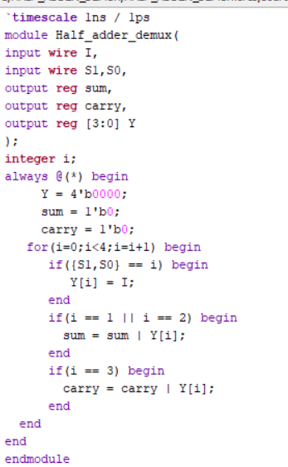

Testbench :The testbench applies all four combinations of select inputs to verify the Sum and Carry outputs with the DEMUX input set to HIGH.

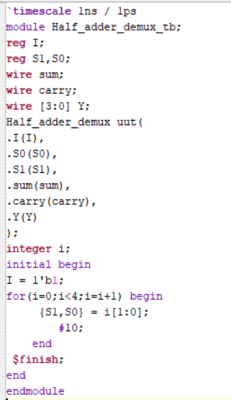

Waveform: The waveform verifies that the Sum output is HIGH when the two inputs are different and the Carry output is HIGH when both inputs are HIGH.

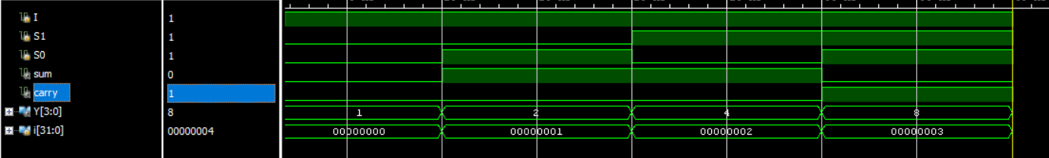

Schematic: The RTL schematic of the Half Adder implemented using DEMUX is generated and analyzed using Xilinx Vivado.

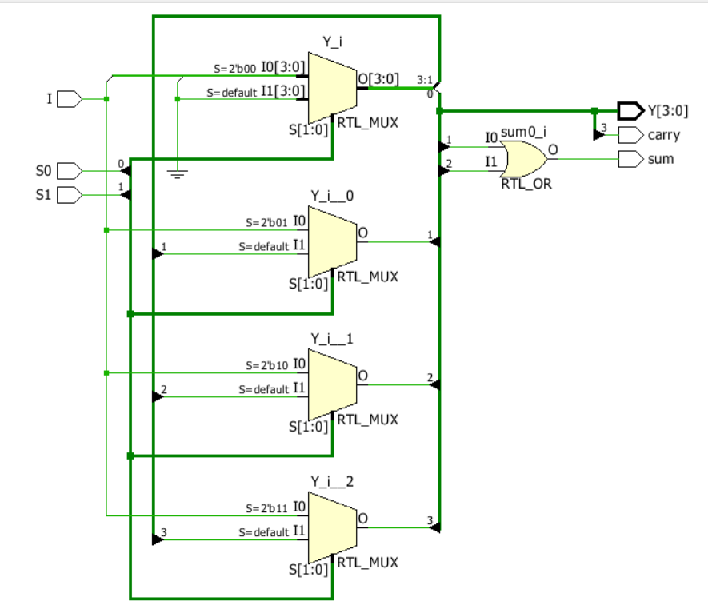

2. Half Subtractor Using DEMUX

Design: A Half Subtractor is a combinational circuit that subtracts one single-bit binary input from another and produces two outputs: Difference and Borrow.
The Difference output is obtained by combining DEMUX outputs Y[1] and Y[2]. The Borrow output is obtained from DEMUX output Y[1].
Boolean Expressions: Difference = A ⊕ B Borrow = A' · B
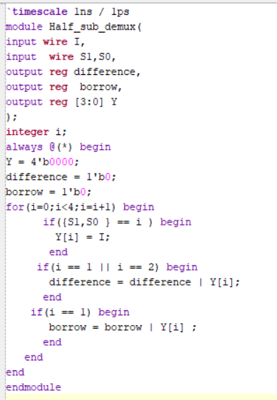

Testbench: The testbench applies all four combinations of select inputs to verify the Difference and Borrow outputs with the DEMUX input set to HIGH.

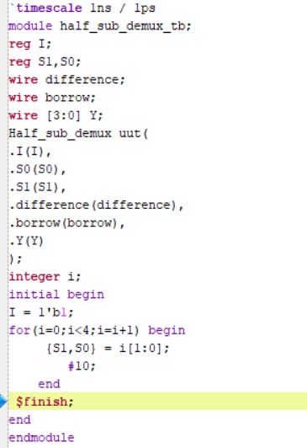

Waveform: The waveform verifies that the Difference output is HIGH when the two inputs are different and the Borrow output is HIGH when A = 0 and B = 1.

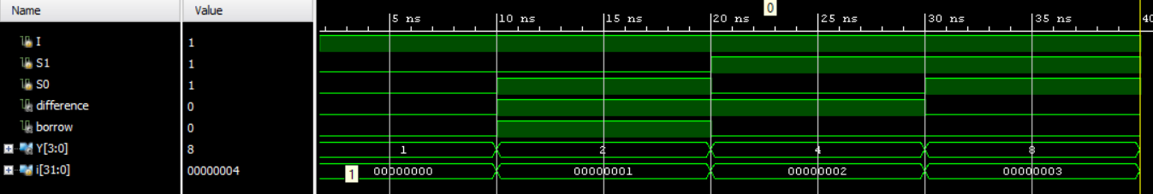

Schematic: The RTL schematic of the Half Subtractor implemented using DEMUX is generated and analyzed using Xilinx Vivado.

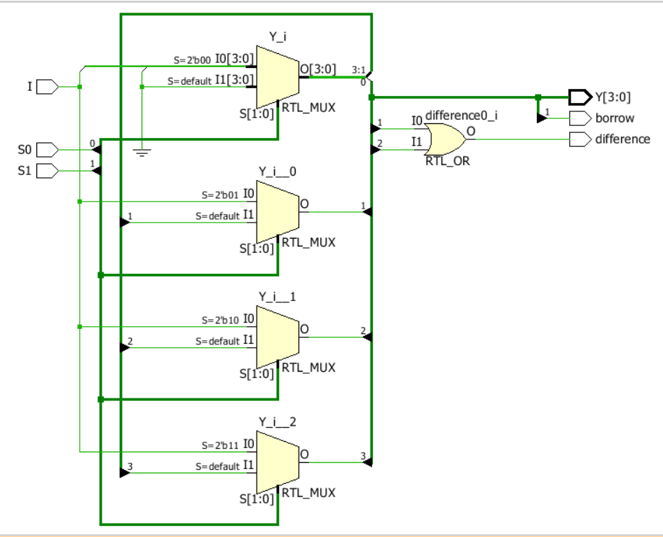

Observation: The Half Adder and Half Subtractor were implemented using DEMUX-based logic and verified through simulation. This experiment improved my understanding of binary arithmetic, Boolean expressions, and combinational circuit design using Verilog HDL.

#PHANEENDRA.SINGUDASU

